August 2025

HAPPENINGS AT HOME

Residents, Staff and Family



***Celebrating August***

* Barbeque Month
* Safety Talk
* Employee Spotlight
* Day & Stay Program
* Volunteer Needed
* Lemonade Stand
* Family Council
* Resident Survey
* Summer Gardening

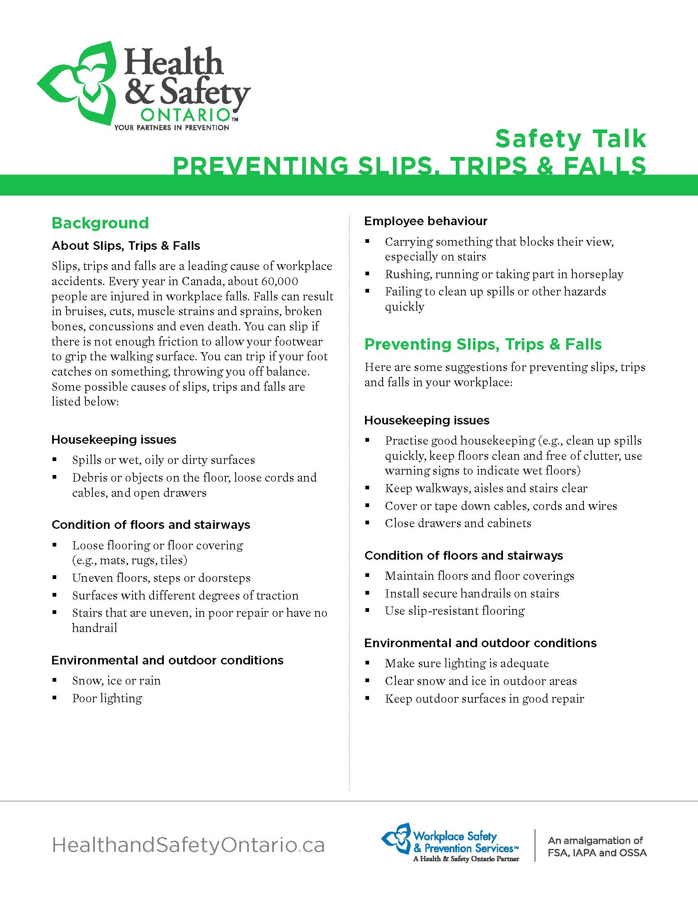

***Safety Talk***

***Employee Spotlight***

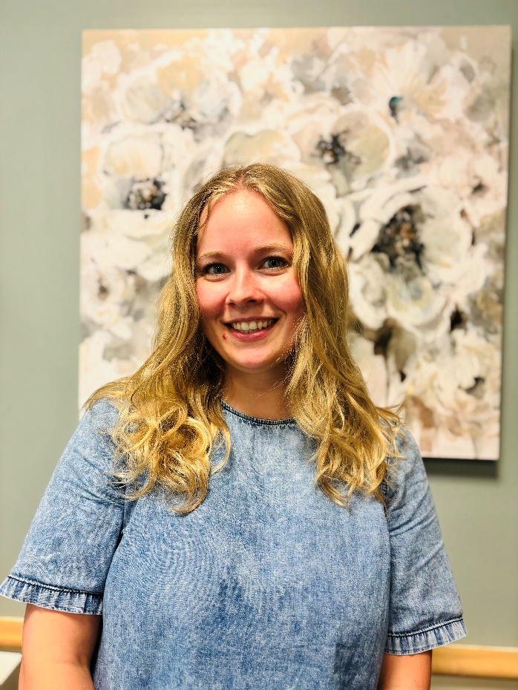

Stephanie was nominated by her colleagues and caregivers for the Employee Spotlight Award. Stephanie is a Recreation Assistant on Davis Court. Caregivers recognize Stephanie for her energy, creativity and compassion she brings to all her programs and interactions with residents.  Stephanie’s colleagues say she is always willing to work as a team, her compassion, kindness, empathy, humour, and positive personality makes working with Stephanie a joy to be around. Stephanie is always willing to lend a hand to anyone who is in need.  Stephanie’s presence makes a meaningful difference each day to residents, families and staff alike.

***Day & Stay Program***

We are now into the month of August and the staff and clients have been enjoying every moment of this beautiful summer weather. Even with the heat waves, we have been tending to our little garden and going outside when the temperatures were comfortable. The clients have enjoyed singing in the garden with our new song books we have created that are composed of all the golden hits they love.

Many of our clients speak of past camping trips and time spent at a favorite lakeside cottage. To remember this special time the Day & Stay will be celebrating the great outdoors with camping week. The clients will be busy setting up a campsite, making smores and putting their survival knowledge to the test with some engaging camping themed programs.

Moving into fall we are preparing for the county fair season. We dedicate an entire week to remembering everything about our local fairs from the activities, rides and food! The clients have the opportunity to go through the Paris Fair entry book and decide on some items the groups can enter into the fair. This usually includes arts and craft, plants and produce and even home- made pies! The group has an impressive past of some first-place ribbons and we hope to add some more to our collection!

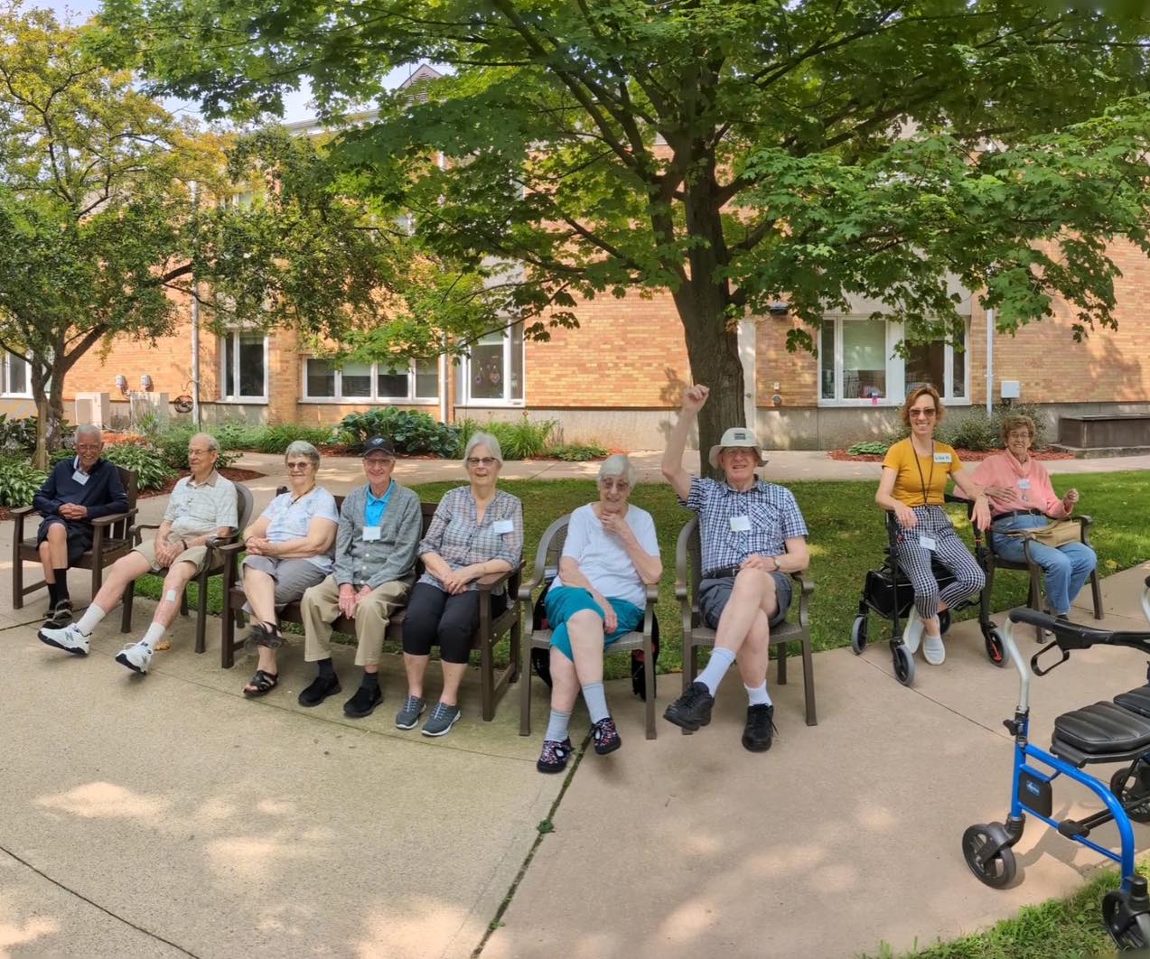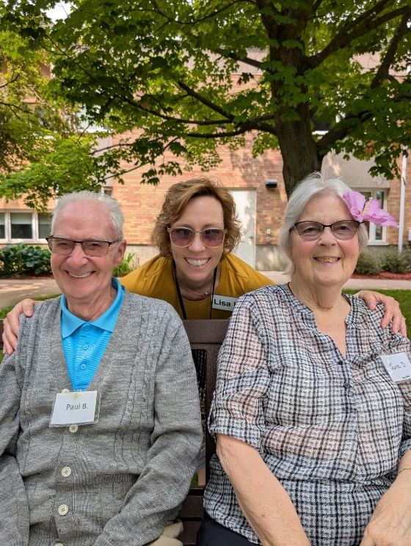

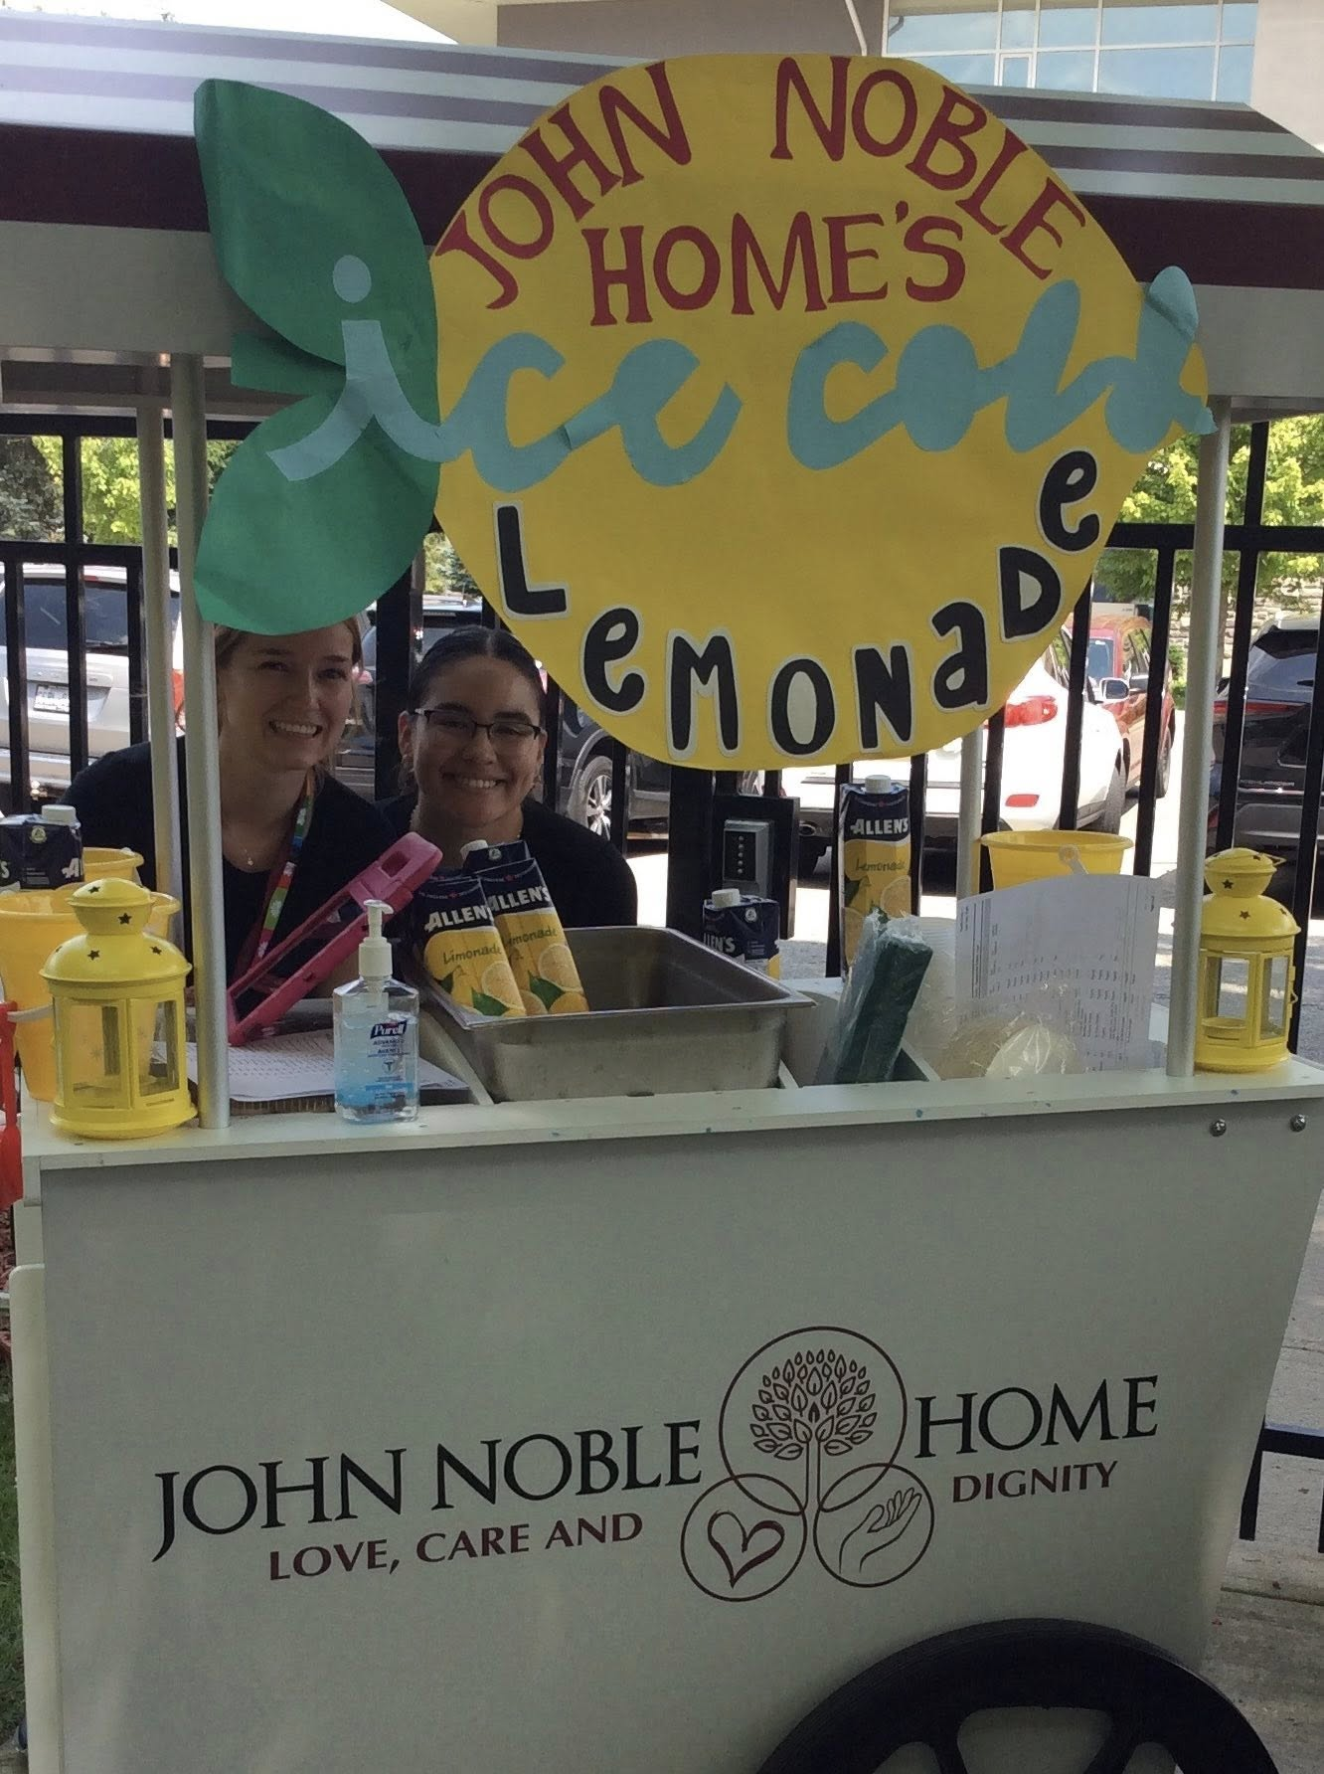

Celebrating summer with our Lemonade Stand. 🤍🍋

Thanks to our Staff, Residents and Families for making it a wonderful time!

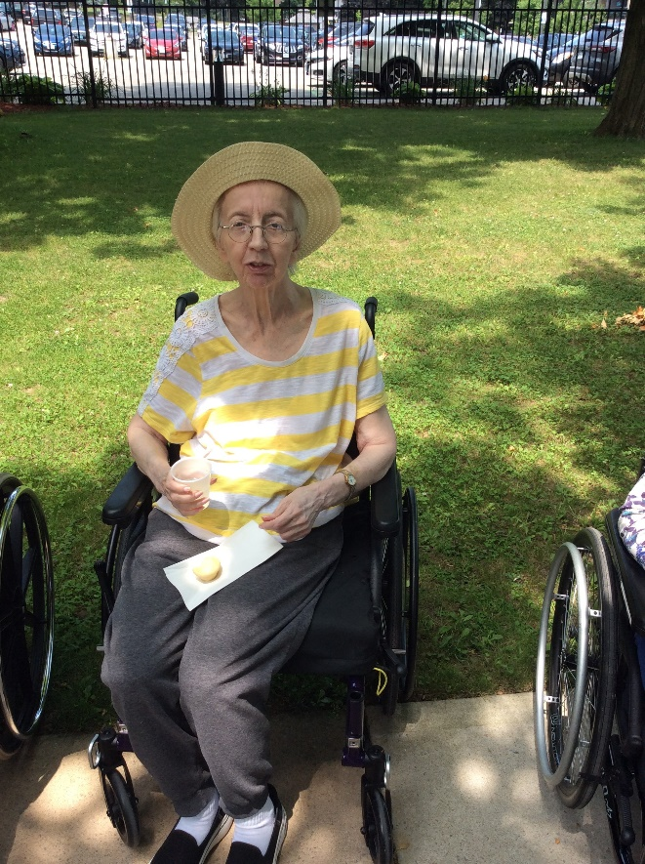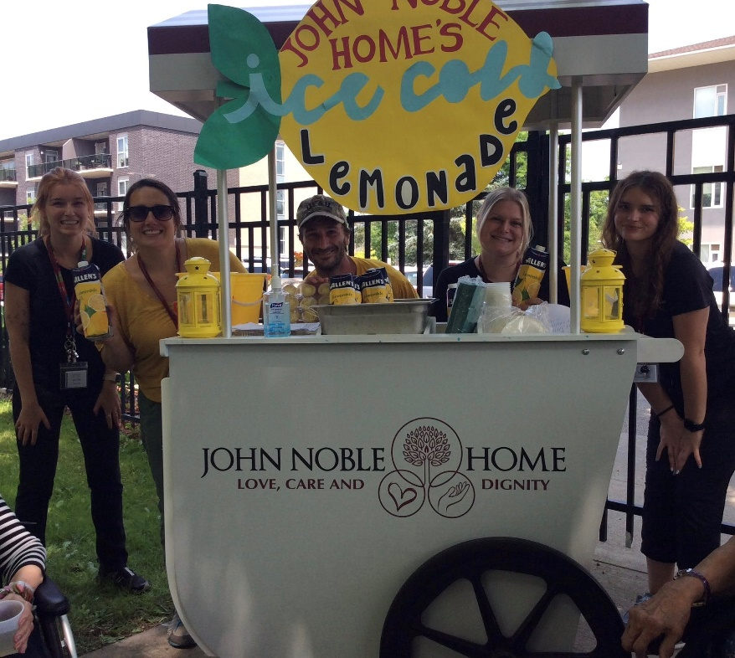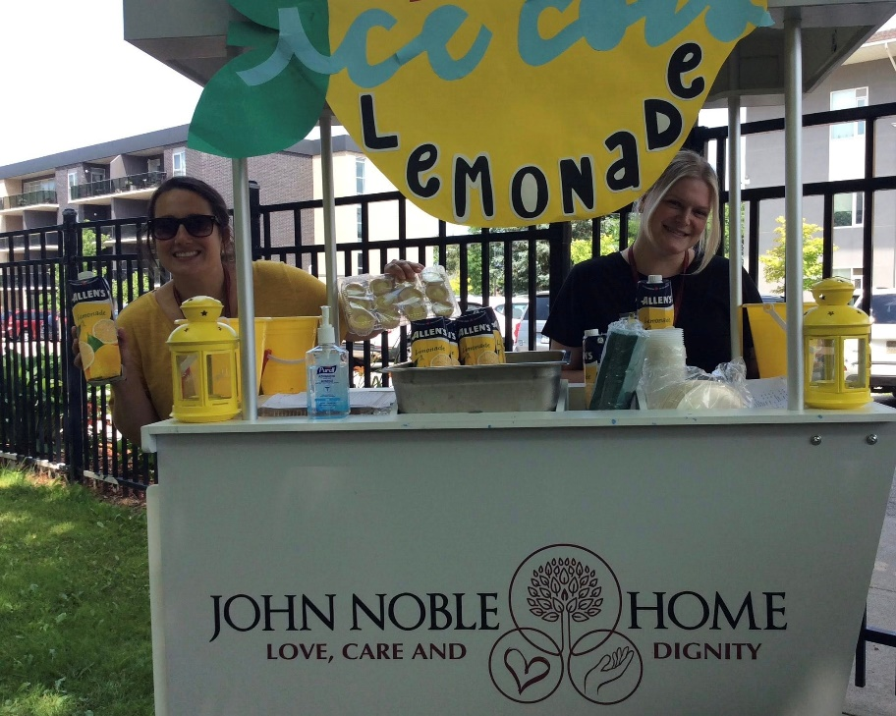

***SUCCEED AS ONE***

***JOIN US***

**Share your ideas to**

**Help Enrich the Lives of our Loved One’s**

**For more information contact:**

**Karli Cass at 519-756-2920 ext 4241**

***FAMILY FORUM***

***WHO ARE WE***

* The John Noble Home Family Forum consists of family members of residents.
* We function as a support group and a bridge between families and John Noble Home.
* The Forum provides peer support, shares ideas, and collaborates for residents' well-being.
* We offer suggestions to staff to improve services and activities for residents and their families.
* We meet once a month* for approx. 1.5 hours in a relaxing and friendly atmosphere.

*\*See meeting notice on each floor for time and location.*

**RESIDENT SURVEY:**

**PLEASE BE ON THE**

**LOOKOUT FOR OUR**

**ANNUAL RESIDENT**

**SATISFACTION**

**SURVEY HAPPENING IN AUGUST**

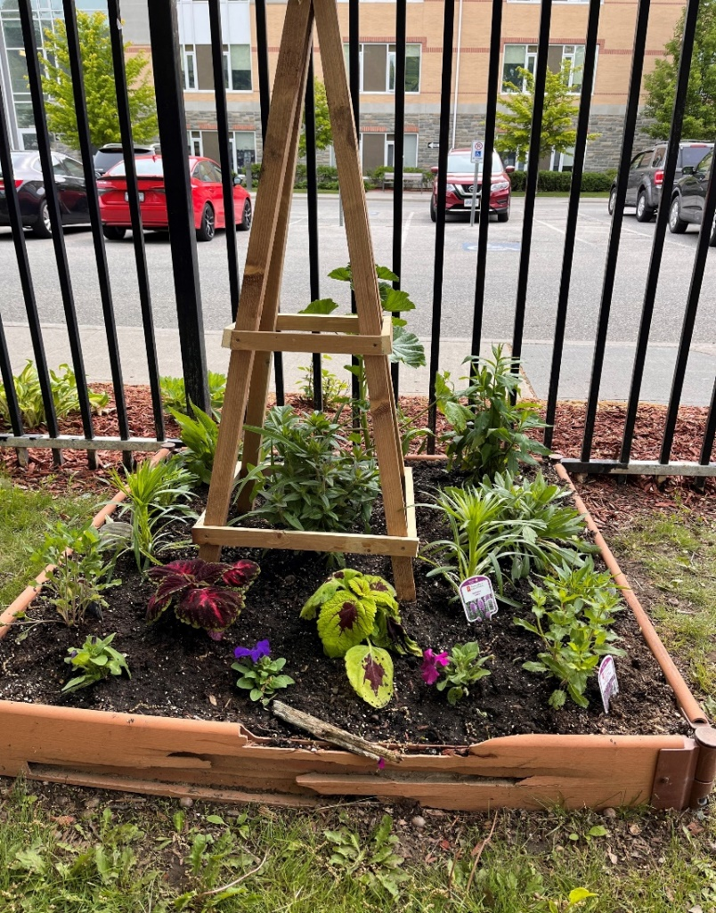 **FAMILY & RESIDENT COUNCIL**

**There is a lovely garden of flowers and vegetables that are being maintained by Volunteers that are on the Family Council and Resident Council.**

**Thank you for all that have participated. Everything looks lovely.**

