Day and Stay Day and Weekend Programs |  |  | 9:00 What’s New  10:00 Tell Me  10:30 Ukulele Playing  1:00 Fun & Fitness  2:00 Shake Loose a Memory  4:00 Let’s Read  6:15 Around the Table  7:00 Bean Bag Toss | 9:00 Current Events  10:00 Take a Guess  10:30 Music Bingo  1:00 Exercise  2:00 Outburst  4:00 Card Games  6:15 Around the Table  7:00 Crossword | Sandwich Day  9:00 In the News  10:00 Name the Sandwich  10:30 Make your Own Sandwich  1:00 Ole Exercises  2:00 Sandwich Puzzle  4:00 Swatter Ball  6:15 Around the table  7:00 Can You Picture This? | 9:00 Morning News  10:00 YouTube Trivia  10:30 Music Bingo  1:00 Exercise Time  2:00 Card Games  3:00 Shake Loose a Memory  6:15 Around the Table  7:00 Word Probe
9:00 Current Events  10:00 Tell Me  10:30 Dice Roll  1:00 Let’s Get Moving  2:00 Golf  3:00 Let’s Read  6:15 Around the Table  7:00 bingo Night | Cinnamon Day  9:00 What’s New  10:00 Cinnamon Facts  10:30 Baking Cinnamon Rolls  1:00 Fun & Fitness  2:00 Making Cinnamon Potpourri  4:00 Swatter Ball  6:15 Around the Table  7:00 Bowling | 9:00 What’s New  10:00 Tell Me  10:30 Crossword  1:00 Fun & Fitness  2:00 Card Games  4:00 Let’s Read  6:15 Around the Table  7:00 Golf | 9:00 In the News  10:00 What Am I?  10:30 Wheel of Fortune  1:00 Ole Exercises  2:00 Can You Picture This?  4:00 Outburst  6:15 Let’s Read  7:00 Spelling Bee | 9:00 What’s New  10:00 Random Trivia  10:30 Wheel of Fortune  1:00 Fun & Fitness  2:00 Shake Loose a Memory  4:00 Bingo  6:15 Around the Table  7:00 Penny Snatch | We Remember  9:00 Current Events  10:00 Trivia & Facts  10:30 Making Poppy Seed Bread  1:00 Exercises  2:00 Making Veteran’s Cards | Remembrance Day  9:00 Morning News  10:00 We Remember  10:30 Watching the Remembrance Day Service  1:00 Fitness  2:00 Poppy Craft  4:00 Penny Snatch  7:00 Outburst
9:00 Morning Discussion  10:00 Trivia Time  10:30 Morning Games  1:00 Music & Motion  2:00 Wheel of Fortune  3:00 Shuffleboard  6:15 Around the Table  7:00 Bingo | 9:00 Current Events  10:00 Take a Guess  10:30 Dice Roll  1:00 Ole Exercises  2:00 Penny Snatch  4:00 Card Games  6:15 Around the Table  7:00 Sing-A-Long | Pickle Day  9:00 In the News  10:00 All About Pickles  10:30 Making Pickle Cookies  1:00 fun 7 Fitness  2:00 Christmas Pickle Ornament  4:00 bingo  6:15 Around the Table  7:00 Target Toss | 9:00 Morning News  10:00 Random Trivia  10:30 Penny Snatch  1:00 Music & Movement  2:00 Charades  4:00 Let’s Read  6:15 Around the Table  7:00 Guess in 10 | 9:00 Current Events  10:00 Take a Guess  10:30 Table Games  1:00 Ole Exercises  2:00 Reminisce Bingo  4:00 Swatter Ball  6:15 Around the Table  7:00 Bean Bag Toss | World Peace Day  9:00 What’s New  10:00 Peace Probe  10:30 Dove Chain  1:00 Music & Movement  2:00 Peace Poetry  4:00 Bingo  6:15 Around the Table  7:00 Wheel of Fortune | 9:00 In the News  10:00 What Am I?  10:30 Morning Art  1:00 Fun & Fitness  2:00 Shake Loose a Memory  3:00 Let’s Read  6:15 Around the Table  7:00 Karaoke
9:00 In the News  10:00 YouTube Trivia  10:30 Music Morning  1:00 Ole Music & Movement  2:00 Bean Bag Toss  3:00 Name That Tune  6:15 Around the Table  7:00 Bowling | 9:00 Morning News  10:00 Random Trivia  10:30 Karaoke  1:00 Music & Movement  2:00 Family Feud  4:00 Bingo  6:15 Around the Table  7:00 Bowling | 9:00 What’s New  10:00 Who Am I…?  10:30 Dice Roll  1:00 Exercise Time  2:00 Shake Loose a Memory  4:00 Let’s Read  6:15 Around the Table  7:00 Golf | Word Puzzle Wednesday  9:00 Morning News  10:00 Trivia Time  10:30 Complete the Puzzle  1:00 Ole Exercises  2:00 Puzzling Puzzle  4:00 Swatter Ball  6:15 Around the Table  7:00 Can You Picture This? | Hat Day  9:00 In the News  10:00 Name the Hat  10:30 Group Hat Contest  1:00 Sing & Stretch  2:00 Pass the Hat  4:00 Card Games  6:15 Around the Table  7:00 Target Toss | 9:00 Morning News  10:00 Can You Picture This?  10:30 Karaoke  1:00 Music & Motion  2:00 Outburst  4:00 Bingo  6:15 Around the Table  7:00 Spelling Bee | 9:00 Current Events  10:00 Tell Me  10:30 Wheel of Fortune  1:00 Let’s Move It  2:00 Afternoon Games  3:00 Let’s Read  6:15 Around the Table  7:00 Walk About
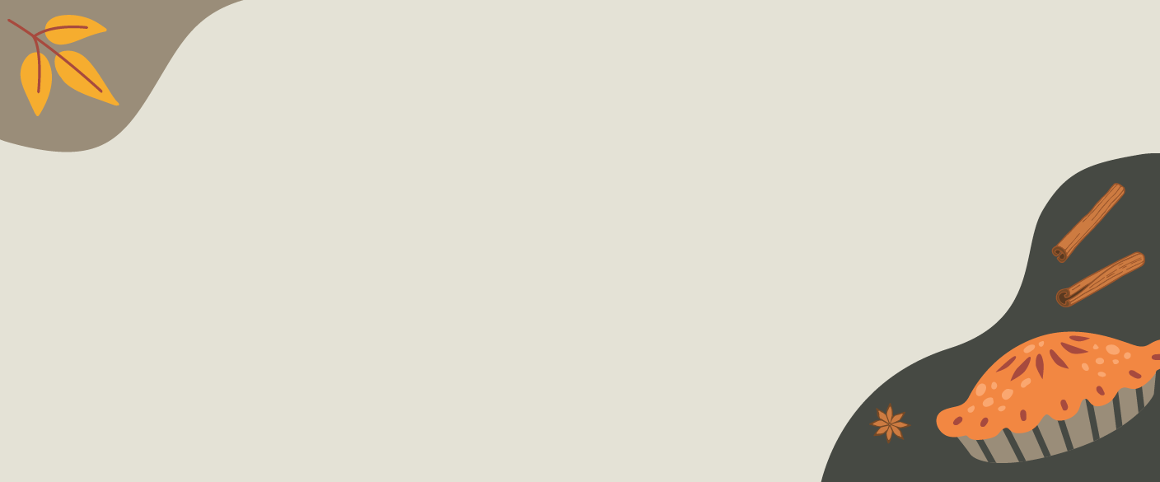  9:00 Morning Discussion  10:00 Take a Guess  10:30 Paint by Number  1:00 Music & Motion  2:00 Outburst  3:00 Puzzle Time  6:15 Around the Table  7:00 Evening Games | 9:00 In the News  10:00 What Am I…?  10:30 Paint by Number  1:00 Let’s Get Moving  2:00 Table Games  4:00 Let’s Read  6:15 Around the Table  7:00 Bowling | 9:00 Current Events  10:00 Tell Me  10:30 Bells  1:00 Ole Exercises  2:00 Bingo  4:00 Outburst  6:15 Table Games  7:00 Penny Snatch | 9:00 In the News  10:00 Take a Guess  10:30 Music Morning  1:00 Sing & Stretch  2:00 Card Games  4:00 Swatter Ball  6:15 Around the Table  7:00 Bells | 9:00 Current Events  10:00 What Am I…?  10:30 Family Feud  1:00 Music & Movement  2:00 Can You Picture This?  4:00 Card Games  6:15 Around the Table  7:00 Wheel of Fortune | We Will Remember
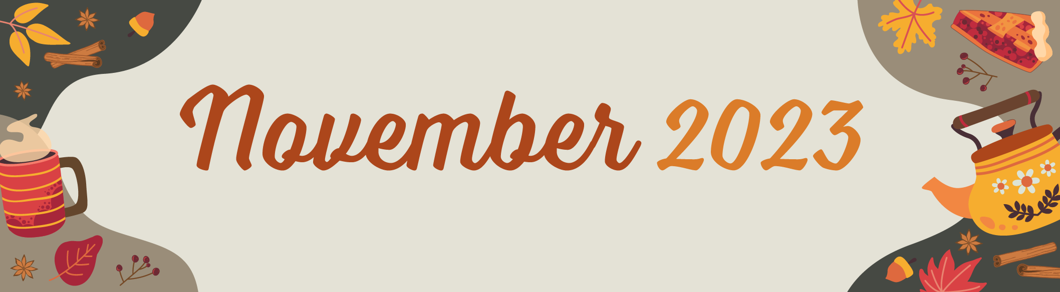
For more information on the Day and Stay Program, please call Lisa Clarkson at (519) 754-4065
Sunday | Monday | Tuesday | Wednesday | Thursday | Friday | Saturday
 |  |  | 1 | 2 | 3 | 4
5 | 6 | 7 | 8 | 9 | 10 | 11  Veterans Day  Remembrance Day (Canada)
12  Diwali (Hindi) | 13 | 14 | 15 | 16 | 17 | 18
19 | 20 | 21 | 22 | 23  Thanksgiving Day (US) | 24 | 25
26 | 27 | 28 | 29 | 30

